10. Sum of Evens

Program Name: sumofevens.ypr
Find the sum of all the even numbers in a list of 10 numbers.

Example Input File
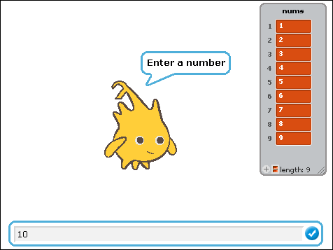

Example Output to Screen
